June 2022 – Technical Task (electron/JavaScript)

The task is to create a small electron app. It will need to install on a windows machine. When the app starts it will play music from a packaged file in a loop. It will allow you to select which audio output devices you want to hear the audio on.

Using multiple monitors, it will allow you to select which monitor to display the app on. By choosing a different monitor it will jump onto that monitor.

The display will be similar to the below

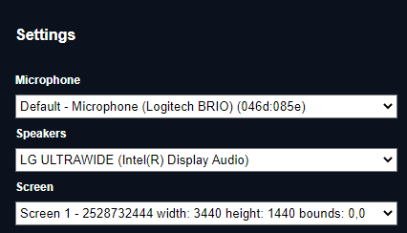

The app will store what you selected so next time it uses the same screen and speakers.